**EXP-6:Construction of Predictive Parsing Table**

**Aim:** Construction of Predictive Parsing Table

**Algortihm:**

**LL(1) Parsing:**  
Here the 1st **L** represents that the scanning of the Input will be done from Left to Right manner and second **L** shows that in this Parsing technique we are going to use Left most Derivation Tree. and finally the **1** represents the number of look ahead, means how many symbols are you going to see when you want to make a decision.

**Code:**

gram = {  
 "E": ["E+T", "T"],  
 "T": ["T*F", "F"],  
 "F": ["(E)", "i"]  
}  
  
  
*def* removeDirectLR(*gramA*, *A*):  
 temp = *gramA*[*A*]  
 tempCr = []  
 tempInCr = []  
 *for* i *in* temp:  
 *if* i[0] == *A*:  
 tempInCr.append(i[1:] + [*A* + "'"])  
 *else*:  
  
 tempCr.append(i + [*A* + "'"])  
 tempInCr.append(["e"])  
 *gramA*[*A*] = tempCr  
 *gramA*[*A* + "'"] = tempInCr  
 *return gramA  
  
  
def* checkForIndirect(*gramA*, *a*, *ai*):  
 *if ai not in gramA*:  
 *return False  
 if a* == *ai*:  
 *return True  
 for* i *in gramA*[*ai*]:  
 *if* i[0] == *ai*:  
 *return False  
 if* i[0] *in gramA*:  
 *return* checkForIndirect(*gramA*, *a*, i[0])  
 *return False  
  
  
def* rep(*gramA*, *A*):  
 temp = *gramA*[*A*]  
 newTemp = []  
 *for* i *in* temp:  
 *if* checkForIndirect(*gramA*, *A*, i[0]):  
 t = []  
 *for* k *in gramA*[i[0]]:  
 t = []  
 t += k  
 t += i[1:]  
 newTemp.append(t)  
  
 *else*:  
 newTemp.append(i)  
 *gramA*[*A*] = newTemp  
 *return gramA  
  
  
def* rem(*gram*):  
 c = 1  
 conv = {}  
 gramA = {}  
 revconv = {}  
 *for* j *in gram*:  
 conv[j] = "A" + str(c)  
 gramA["A" + str(c)] = []  
 c += 1  
  
 *for* i *in gram*:  
 *for* j *in gram*[i]:  
 temp = []  
 *for* k *in* j:  
 *if* k *in* conv:  
 temp.append(conv[k])  
 *else*:  
 temp.append(k)  
 gramA[conv[i]].append(temp)  
  
 *for* i *in* range(c - 1, 0, -1):  
 ai = "A" + str(i)  
 *for* j *in* range(0, i):  
 aj = gramA[ai][0][0]  
 *if* ai != aj:  
 *if* aj *in* gramA *and* checkForIndirect(gramA, ai, aj):  
 gramA = rep(gramA, ai)  
  
 *for* i *in* range(1, c):  
 ai = "A" + str(i)  
 *for* j *in* gramA[ai]:  
 *if* ai == j[0]:  
 gramA = removeDirectLR(gramA, ai)  
 *break* op = {}  
 *for* i *in* gramA:  
 a = str(i)  
 *for* j *in* conv:  
 a = a.replace(conv[j], j)  
 revconv[i] = a  
  
 *for* i *in* gramA:  
 l = []  
 *for* j *in* gramA[i]:  
 k = []  
 *for* m *in* j:  
 *if* m *in* revconv:  
 k.append(m.replace(m, revconv[m]))  
 *else*:  
 k.append(m)  
 l.append(k)  
 op[revconv[i]] = l  
  
 *return* op  
  
  
result = rem(gram)  
terminals = []  
*for* i *in* result:  
 *for* j *in* result[i]:  
 *for* k *in* j:  
 *if* k *not in* result:  
 terminals += [k]  
terminals = list(set(terminals))  
  
  
*def* first(*gram*, *term*):  
 a = []  
 *if term not in gram*:  
 *return* [*term*]  
 *for* i *in gram*[*term*]:  
 *if* i[0] *not in gram*:  
 a.append(i[0])  
 *elif* i[0] *in gram*:  
 a += first(*gram*, i[0])  
 *return* a  
  
  
firsts = {}  
*for* i *in* result:  
 firsts[i] = first(result, i)  
  
  
*def* follow(*gram*, *term*):  
 a = []  
 *for* rule *in gram*:  
 *for* i *in gram*[rule]:  
 *if term in* i:  
 temp = i  
 indx = i.index(*term*)  
 *if* indx + 1 != len(i):  
 *if* i[-1] *in* firsts:  
 a += firsts[i[-1]]  
 *else*:  
 a += [i[-1]]  
 *else*:  
 a += ["e"]  
 *if* rule != *term and* "e" *in* a:  
 a += follow(*gram*, rule)  
 *return* a  
  
  
follows = {}  
*for* i *in* result:  
 follows[i] = list(set(follow(result, i)))  
 *if* "e" *in* follows[i]:  
 follows[i].pop(follows[i].index("e"))  
 follows[i] += ["$"]  
  
resMod = {}  
*for* i *in* result:  
 l = []  
 *for* j *in* result[i]:  
 temp = ""  
 *for* k *in* j:  
 temp += k  
 l.append(temp)  
 resMod[i] = l  
  
tterm = list(terminals)  
tterm.pop(tterm.index("e"))  
tterm += ["$"]  
pptable = {}  
*for* i *in* result:  
 *for* j *in* tterm:  
 *if* j *in* firsts[i]:  
 pptable[(i, j)] = resMod[i[0]][0]  
 *else*:  
 pptable[(i, j)] = ""  
 *if* "e" *in* firsts[i]:  
 *for* j *in* tterm:  
 *if* j *in* follows[i]:  
 pptable[(i, j)] = "e"  
pptable[("F", "i")] = "i"  
toprint = f'{"": <10}'  
*for* i *in* tterm:  
 toprint += f'|{i: <10}'  
print(toprint)  
*for* i *in* result:  
 toprint = f'{i: <10}'  
 *for* j *in* tterm:  
 *if* pptable[(i, j)] != "":  
 toprint += f'|{i + "->" + pptable[(i, j)]: <10}'  
 *else*:  
 toprint += f'|{pptable[(i, j)]: <10}'  
 print(f'{"-":-<76}')  
 print(toprint)

**Output:**

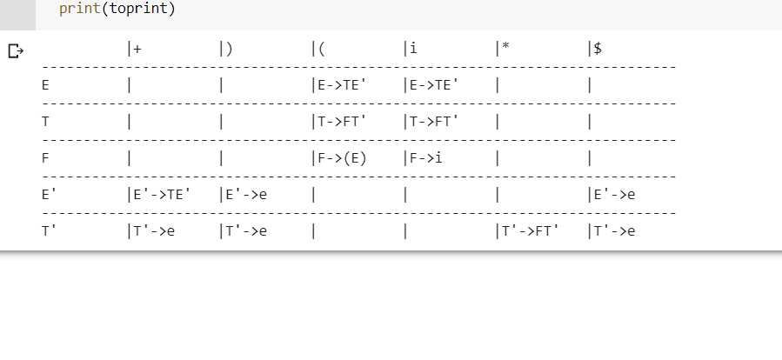

**Result**: Construction of Predictive Parsing Table is Done.